PUBLIC MEETING NOTICE
HARRIS COUNTY EMERGENCY SERVICES DISTRICT NO. 17

Notice is hereby given that the Board of Commissioners of the HARRIS COUNTY EMERGENCY SERVICES DISTRICT NO. 17 will hold a meeting on January 28, 2025 at 9:30 a.m. at the following location in the District: Administration Building, 10410 Airline Dr., Houston, Texas.

The District will consider and act upon the following matters:

- Call meeting to order.
- To receive public comment.
- To approve the Minutes of prior meeting(s).
- To review, discuss and take action regarding review of the terms of the evergreen audit engagement with McCall Gibson Swedlund Barfoot PLLC.
- To review and act on financial matters, including financial report, investments, accounts, depository security, lines of credit, resolutions for account access, and to pay bills.
- To conduct an annual review of the District’s Investment Policy, and take any necessary action.
- To review and act on amendments/revisions to District budgets.
- To review and take action to approve the purchase of capital assets, including apparatus/vehicles, equipment, tools and communications equipment.
- To review and act on disposition of surplus and/or salvage property.
- To review and act on District obligations, including retiring obligations or incurring obligations for construction, real estate, vehicles and equipment.
- To receive a report from Fire Chief on Fire Department activity.
- To review, discuss and act on any issues related to the repairs, improvement, and construction of District facilities, including engaging construction services, change orders and construction payments.
- To review and act on personnel matters, including action on hiring, retention, policies, duties, and benefits.
- To review and act on real estate, including but not limited to purchase, sale, platting, or permits.
- To review and act on any matters regarding dispatch, communications or mutual aid agreements with other agencies.
- To review and discuss annual conflicts of interest requirements under Local Government Code §176.003 (Conflicts Disclosure Statement Required) and §171.004 (Affidavit And Abstention From Voting Required).
- To review and discuss access to personal information under the Public Information Act, including review of sections 552.024, 552.117 and 552.1175
- To meet in Closed Session pursuant to Government Code §551.071 to consult with legal counsel regarding pending or contemplated litigation, settlement offers or on matters which require confidentiality under the Texas Disciplinary Rules of Professional Conduct of the State Bar of Texas and Tax Code §323.3022 to discuss sales tax matters.
- To meet in Closed Session pursuant to Government Code §551.074 to discuss personnel matters.
- To meet in Closed Session pursuant to Government Code §551.072 to deliberate regarding real estate matters.
- To review, discuss and take action regarding matters discussed in the Closed Session.
- To set the date of the next regular meeting.
- Adjournment.

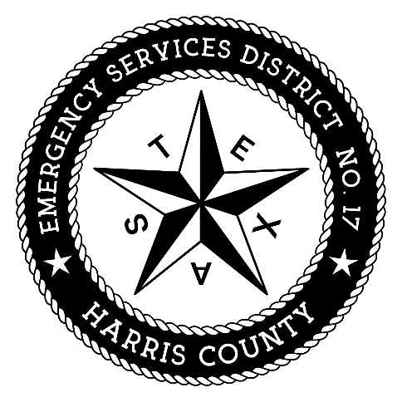
Harris County
Emergency Services District No. 17

By: ______________________________

David J. Manley, District Counsel
Coveler & Peeler, p.c.
Two Memorial City Plaza
820 Gessner, Suite 1710
Houston, Texas 77024
Telephone: (713) 984-8222
Facsimile: (713) 984-0670
Email: manley@coveler.com

