PUBLIC MEETING NOTICE
HARRIS COUNTY EMERGENCY SERVICES DISTRICT NO. 17

Notice is hereby given that the Board of Commissioners of the HARRIS COUNTY EMERGENCY SERVICES DISTRICT NO. 17 will hold a meeting on February 11, 2025 at 9:30 a.m. at the following location in the District: Administration Building, 10410 Airline Dr., Houston, Texas.

The District will consider and act upon the following matters:

- Call meeting to order.
- To receive public comment.
- To review and approve the Minutes of prior meeting(s).
- To review and act on financial matters, including audit, investments, accounts, depository security, lines of credit, resolutions for account access, and to pay bills.
- To review, discuss and take action to approve purchase requests by the Department.
- Adjournment.

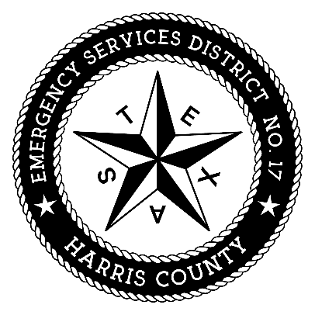
Harris County
Emergency Services District No. 17

By: _____________________________

David J. Manley, District Counsel
Coveler & Peeler, p.c.
Two Memorial City Plaza
820 Gessner, Suite 1710
Houston, Texas 77024
Telephone: (713) 984-8222
Facsimile: (713) 984-0670
Email: manley@coveler.com

